# Code Challenge

# Weekly Bonus – Post/HTML Helper

## Scenario

A software development company gives weekly bonus to its developers based on weekly hours worked on projects and documentations as per following rules –

Weekly Bonus

Project Hours > 20 5000

> 30 1000

Documentation Hours > 5 2500

>10 3700

## Functionalities

1. Display a form to get details

2. Calculate the bonus amount

## Model

**Bonus** model class is already given for your reference.

## Controller

1. A controller named ‘**WeeklyBonusController**’ is given to you.

Implement following 3 actions –

**1. WeeklyBonus(No argument)**

* This action will display a form as shown in the sample below using WeeklyBonus.cshtml.
* The form in the view must be bound to 'Bonus' model.
* On submit, 'WeeklyBonus' action with argument must be invoked. Return type must be ActionResult.

**2) WeeklyBonus (HttpPost)**

* This action will accept 'Bonus' Model as parameter.

##### Calculate the bonus amount based on the values in the model.

* Assign the bonus amount to the property 'Bonus_Amount' in the ‘Bonus' object.
* Display the same view with calculated bonus amount as shown in the sample input/output.

*Note : On this action property POST must be given*

*Return type must be* ***ActionResult*.**

**3) Print**

*Return type must be* ***ActionResult.***

**Implement the following Views:**

**1. WeeklyBonus.cshtml**

a)Create a **form** mapped to Bonus **Model using HTML Helper.**

**NOTE : While creating the form, 'id' MUST be available ( hint : use HTMLHelper )**

id="Emp_ID"

id="Emp_Name"

id="Project_Hours"

id="Documentation_Hours"

id="Submit"

b) Implement a **Link** for **'Print Bonus' .** On clicking this link, the 'Print' action must be invoked and the bonus details must be displayed.

**2) Print.cshtml**

This view must display the values in the WeeklyBonus object as shown below.

*Hint: You are free to choose ANY CSS look and feel.*

**Sample Input/Output**

**URI**

**WeeklyBonus/WeeklyBonus**

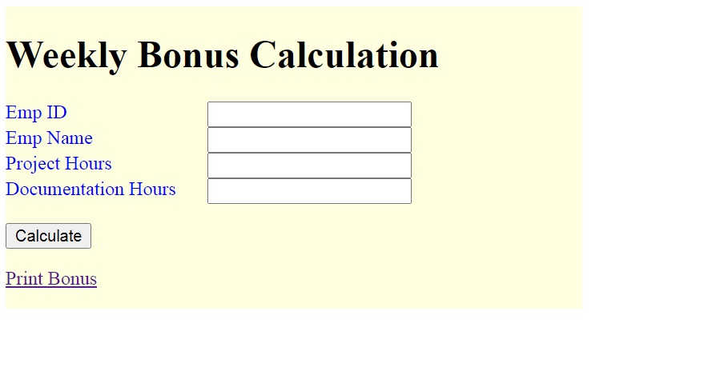

After clicking on Calculate button, bonus amount should be calculated and displayed.

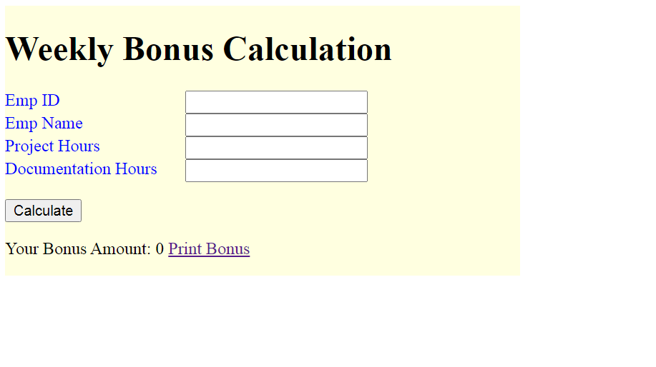

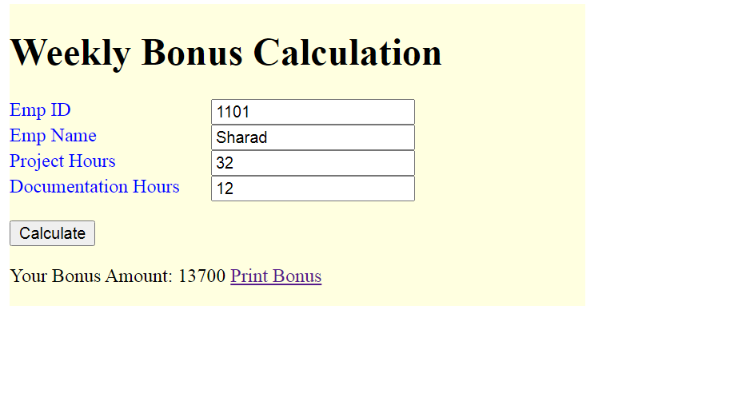

Clicking on **Print Bonus** link should display Bonus details using Print Action.

